# LIMS Invoice and Data Grabber installation and use

**INSTALLATION:**

Please ensure you have Cisco AnyConnect VPN client installed. To get Cisco VPN, contact Spicsoft and ask for a connection to Calabs and request an account.

The Invoice and Data Grabber application is installed and distributed on the Citrix Server. Please open up Citrix Receiver or access Citrix using the webapp found on:

<http://calserver-vm1.calabs.local/Citrix/calabsWeb/>

**FOR USE:**

1. Open the LIMS Invoice grabber on Citrix

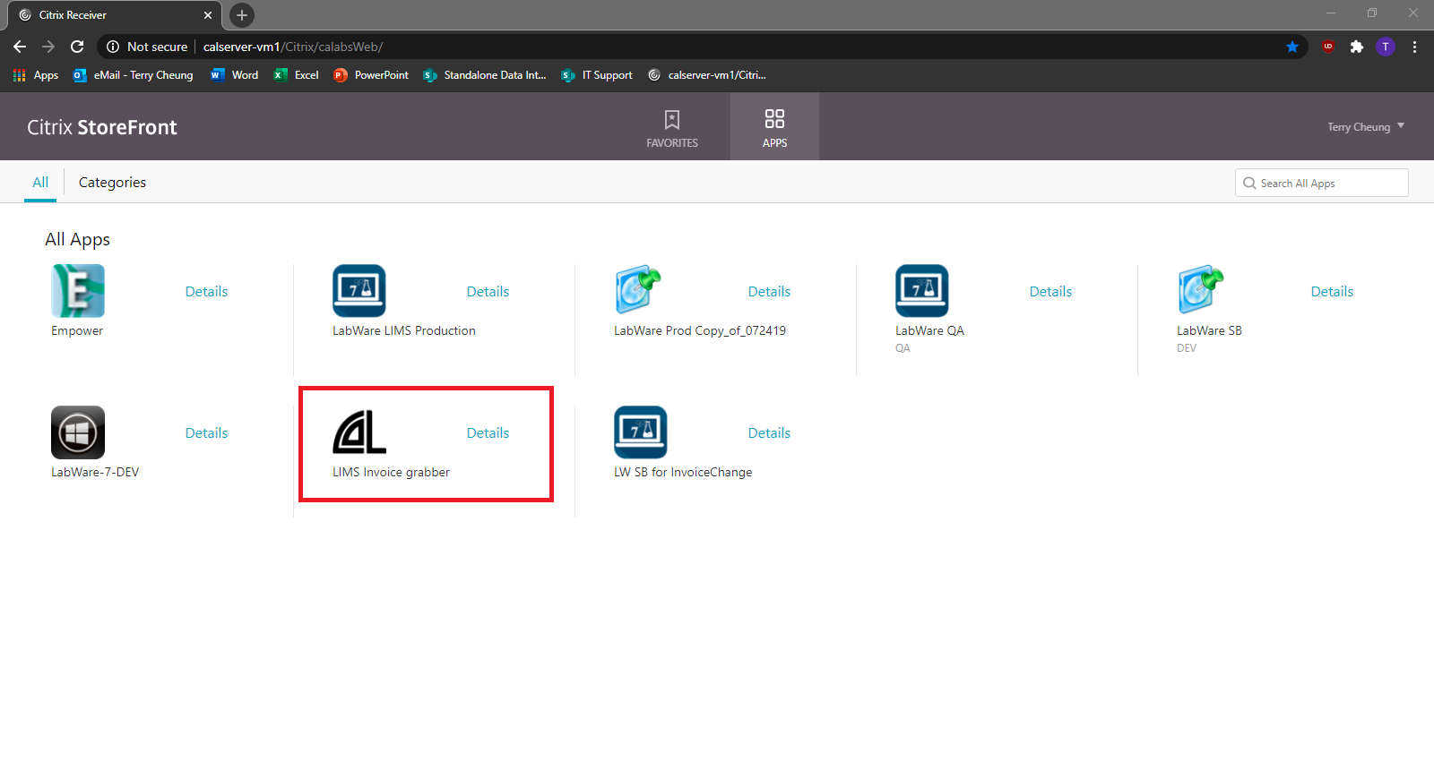

1. Select the appropriate server name. (Default Selection is

“calqa02 LabWare-7-072419”)

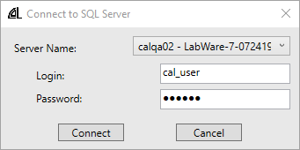

1. Click “Connect”

#### To search for detailed invoice items:

1. Enter desired fields (at least 1 field needs to be filled)

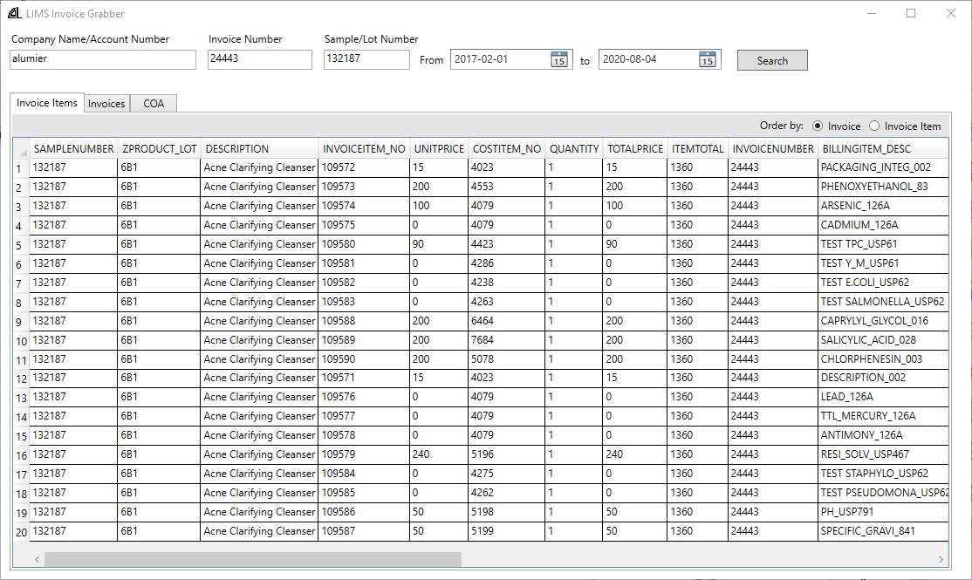

1. Detailed view and Sample Submission Form is available by right clicking and selecting from menu

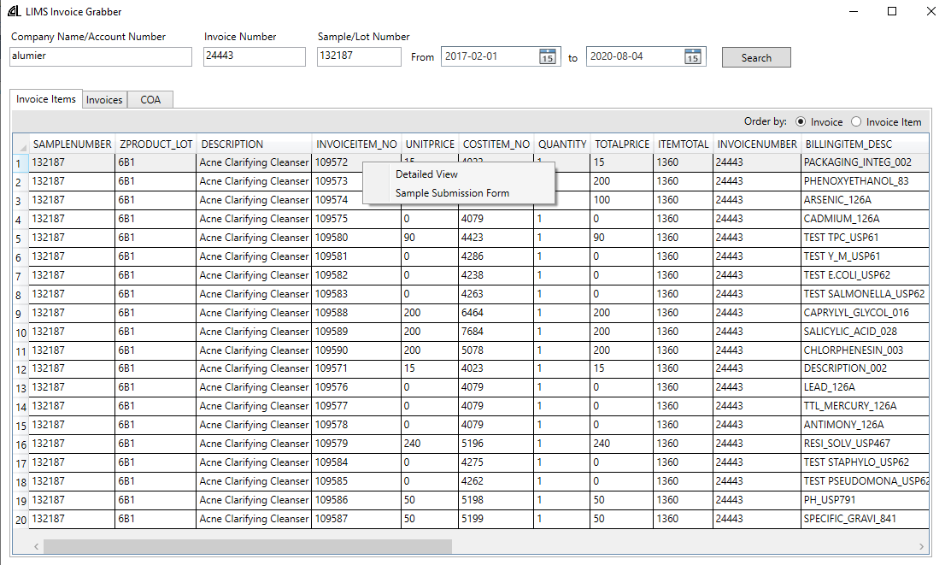

Detailed view:

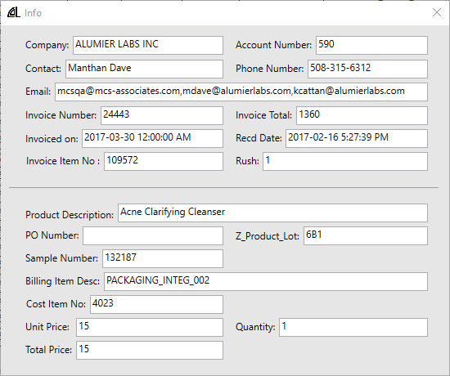

Sample Submission Form (in PDF format):

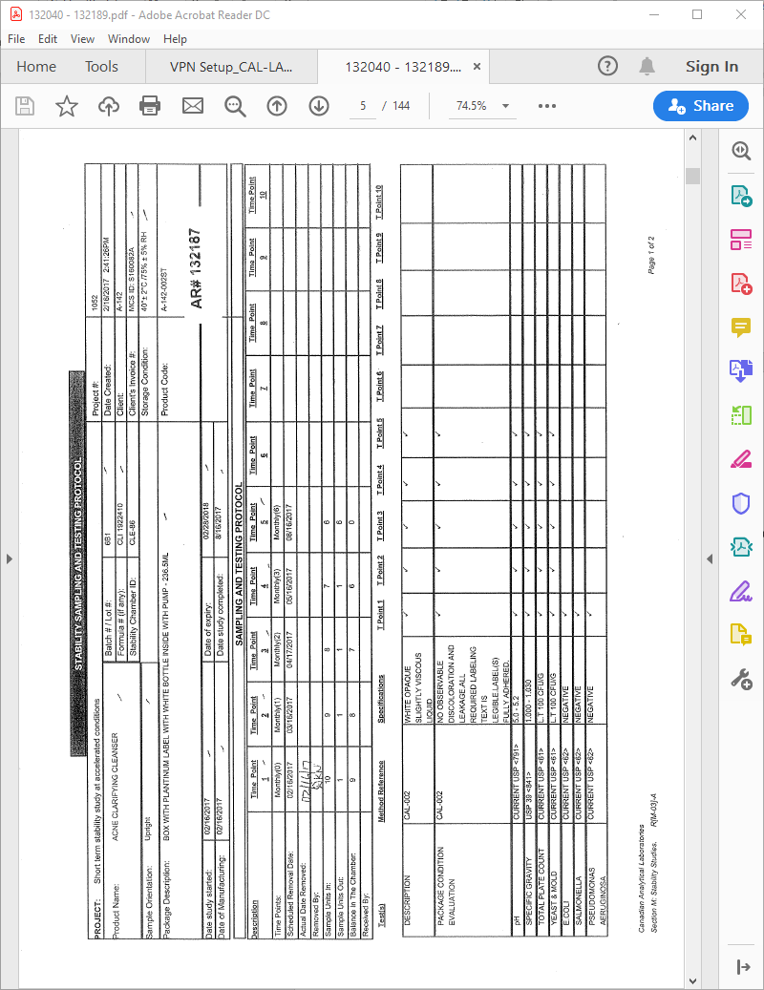

**To generate Revenue Report:**

1. Order by “Invoice Item”

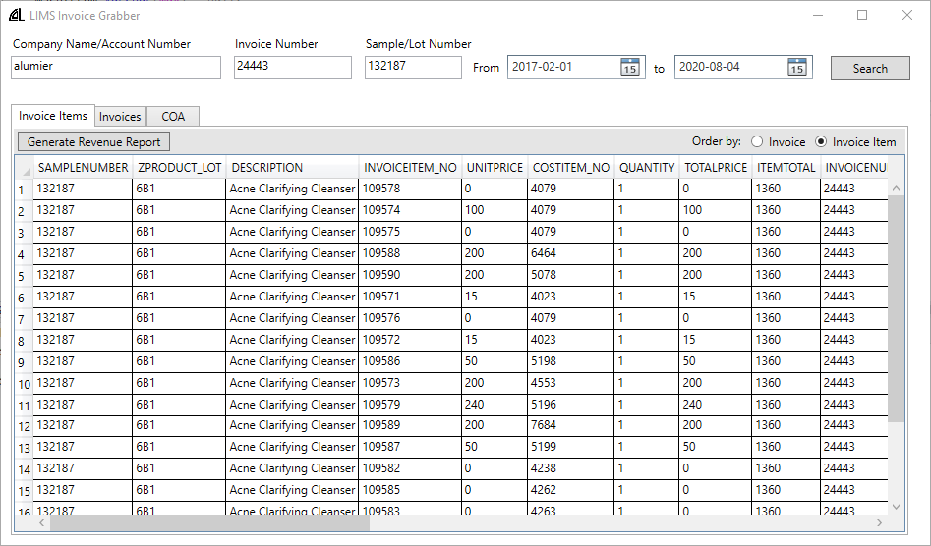

1. Click “Generate Revenue Report”

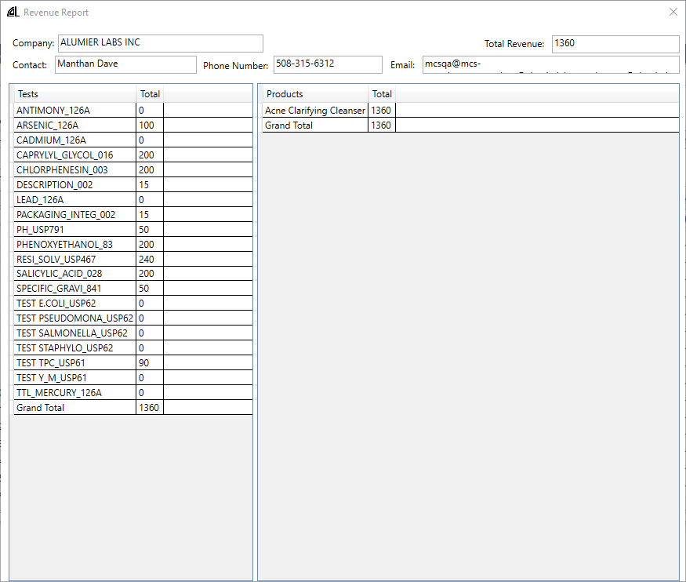

To search for invoices:

1. Enter desired fields (at least 1 field needs to be filled)

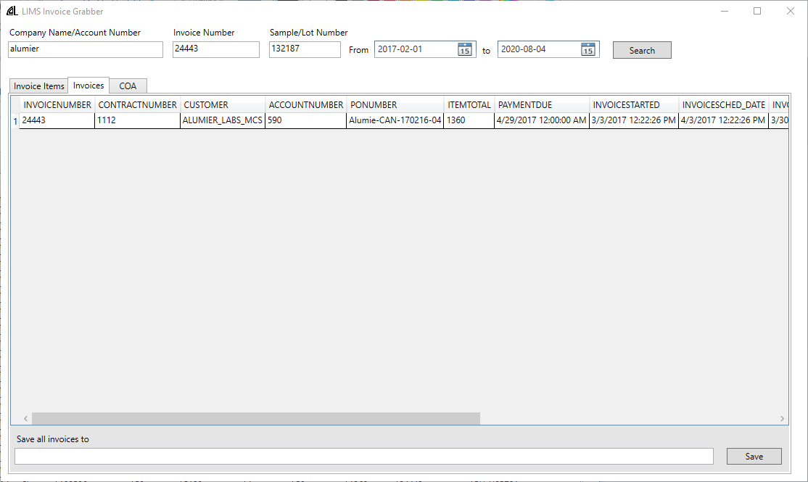

1. Save all invoices by clicking “Save”
2. Select location to save zip file (Please select your personal drives labeled with brackets)

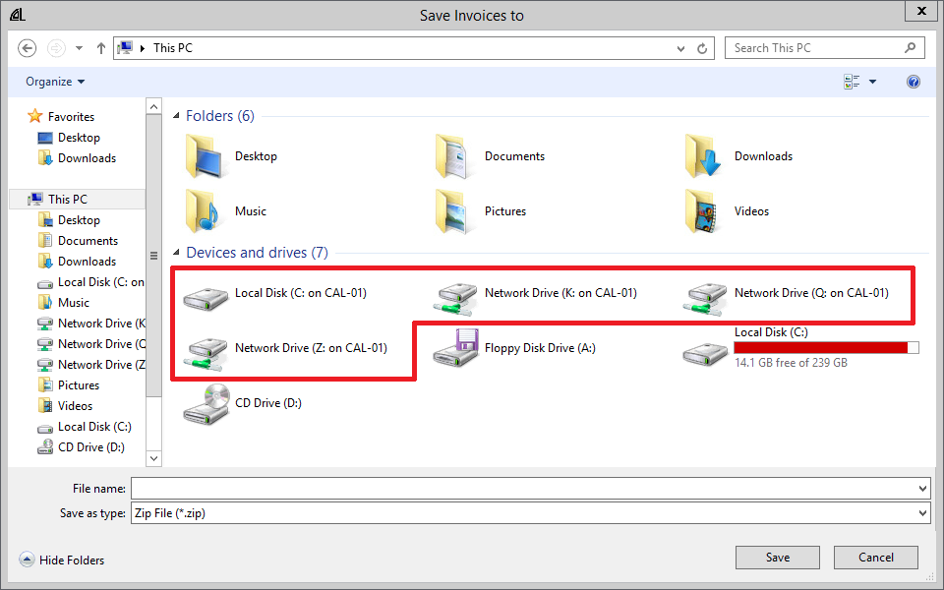

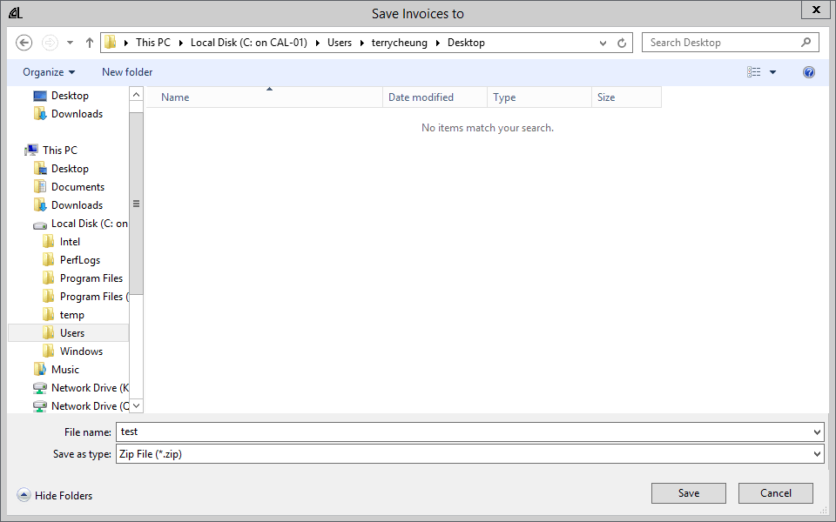

1. For individual or custom selection of invoices, select desired invoices and right-click to save as zip

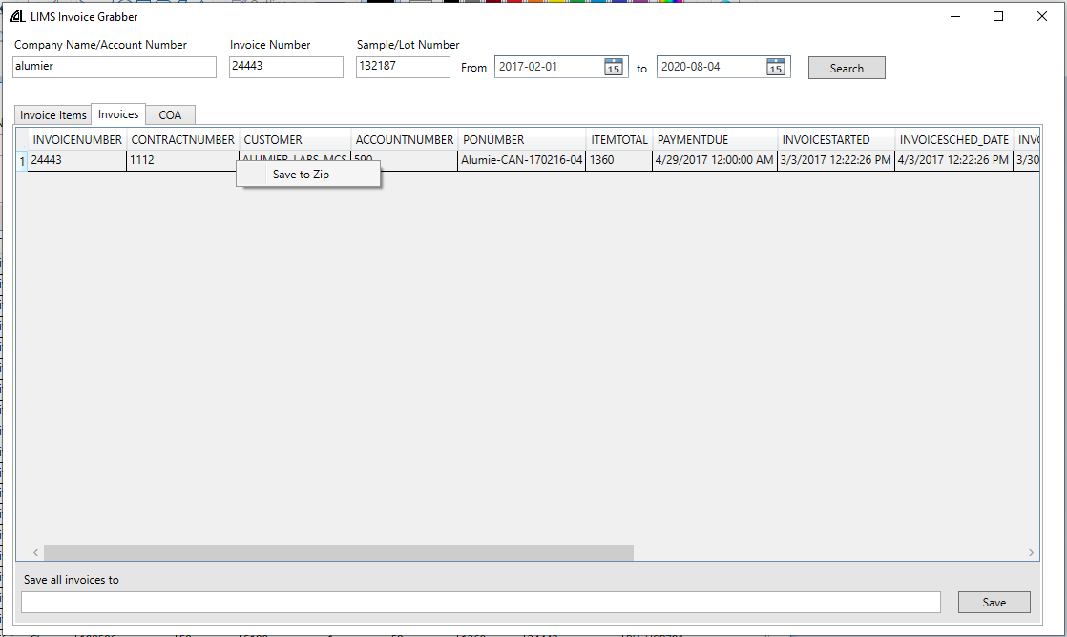

For Certificate Of Analysis (COA):

1. Enter desired fields (COA cannot be searched by invoice and is therefore ignored)

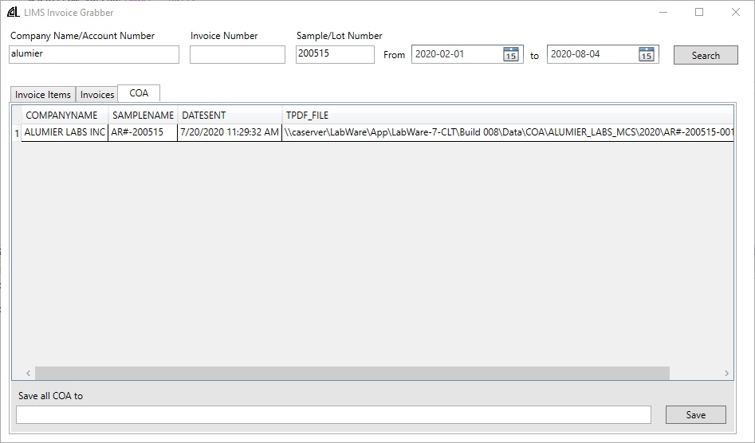

1. To save all COAs click “Save”
2. Select location to save zip file (Please select your personal drives labeled with brackets)

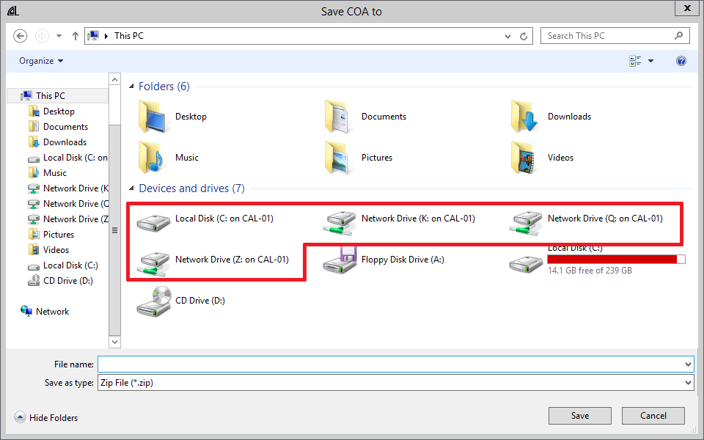

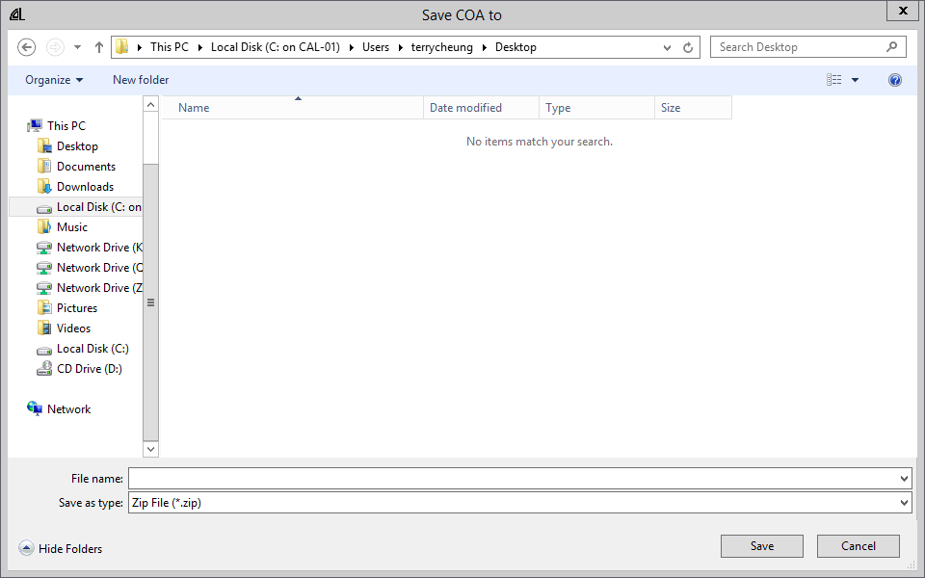

1. For individual or custom selection of COAs, select desired invoices and right-click to save as zip

